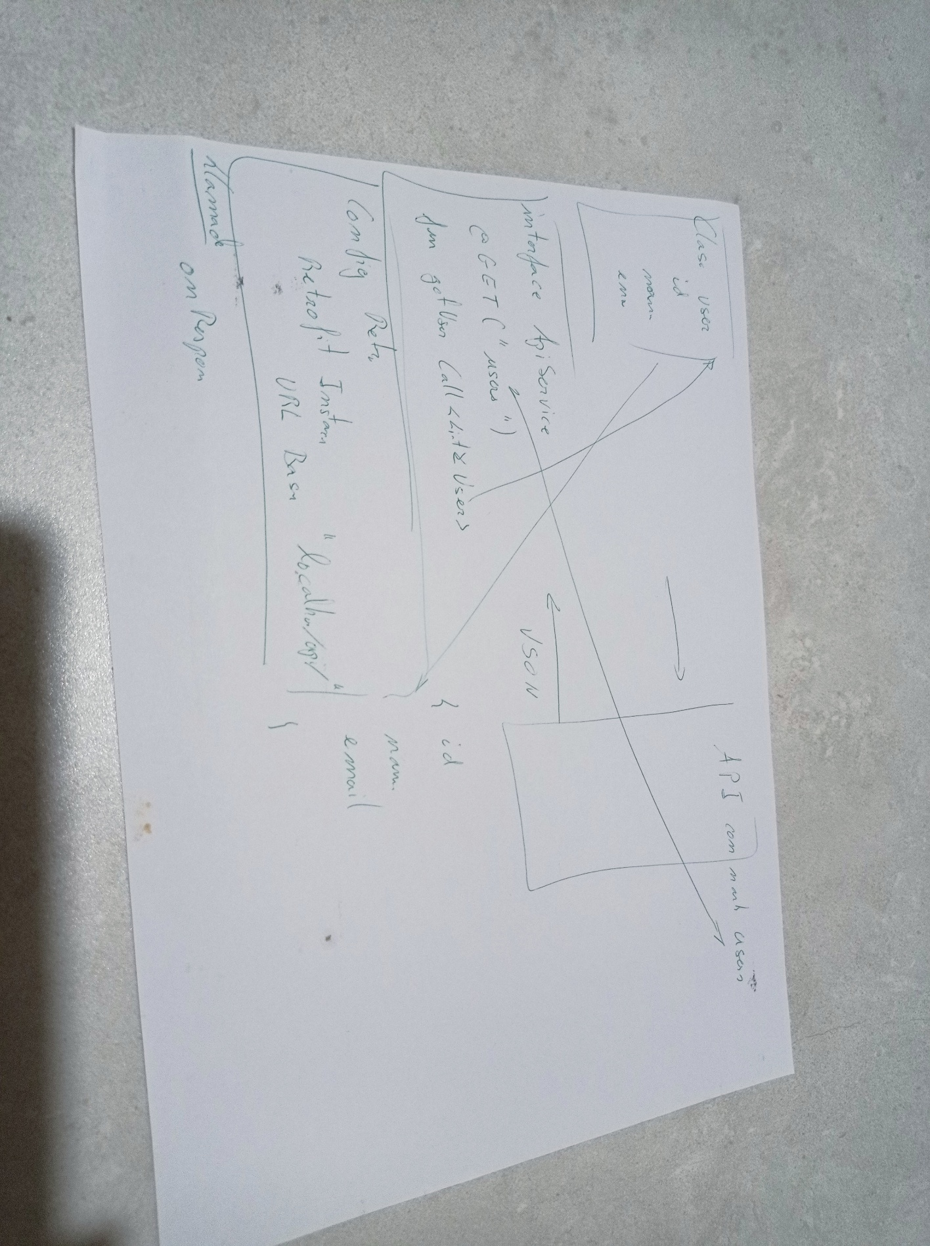

🔹 1️⃣ Backend PHP con JWT
Para este ejemplo usaremos PHP puro con la librería firebase/php-jwt para generar y verificar JWT.
📦 Instalar librería
Si tienes Composer:
composer require firebase/php-jwt

📄 api.php (backend)
<?php
require 'vendor/autoload.php';
use \Firebase\JWT\JWT;
use \Firebase\JWT\Key;
header('Content-Type: application/json');
header('Access-Control-Allow-Origin: *');
header('Access-Control-Allow-Methods: POST, GET, OPTIONS');
header('Access-Control-Allow-Headers: Content-Type, Authorization');
$method = $_SERVER['REQUEST_METHOD'];
$secret_key = "mi_clave_super_secreta";
// Leer la ruta
$request = $_SERVER['REQUEST_URI'];
$path = parse_url($request, PHP_URL_PATH);
// Leer el body JSON
$input = json_decode(file_get_contents('php://input'), true);
if ($path === '/api/login' && $method === 'POST') {
$username = $input['username'] ?? '';
$password = $input['password'] ?? '';
// Simulamos usuario válido
if ($username === 'umar' && $password === '1234') {
$payload = [
"user" => $username,
"iat" => time(),
"exp" => time() + 3600 // 1 hora de duración
];
$jwt = JWT::encode($payload, $secret_key, 'HS256');
echo json_encode(["accessToken" => $jwt]);
} else {
http_response_code(401);
echo json_encode(["error" => "Credenciales incorrectas"]);
}
} elseif ($path === '/api/usuario' && $method === 'GET') {
// Leer token desde cabecera Authorization
$headers = getallheaders();
if (!isset($headers['Authorization'])) {
http_response_code(401);
echo json_encode(["error" => "Token requerido"]);
exit;
}
$authHeader = $headers['Authorization'];
$token = str_replace("Bearer ", "", $authHeader);
try {
$decoded = JWT::decode($token, new Key($secret_key, 'HS256'));
echo json_encode([
"id" => 1,
"nombre" => $decoded->user,
"email" => $decoded->user . "@mail.com"
]);
} catch (Exception $e) {
http_response_code(403);
echo json_encode(["error" => "Token inválido o expirado"]);
}
} else {
http_response_code(404);
echo json_encode(["error" => "Ruta no encontrada"]);
}✅ Con esto tienes dos endpoints:
- POST /api/login → devuelve { accessToken: <jwt> }
- GET /api/usuario → requiere token en la cabecera Authorization: Bearer <jwt>

🔹 2️⃣ Android Java + Retrofit
El flujo en Android no cambia mucho respecto al ejemplo anterior. Solo asegurémonos de usar la IP correcta si pruebas localmente:
- Si usas emulador Android, la IP de tu PC es 10.0.2.2.
- Si usas dispositivo físico, usa la IP de tu PC en la red local.

2.1 Dependencias (build.gradle)
implementation 'com.squareup.retrofit2:retrofit:2.9.0' implementation 'com.squareup.retrofit2:converter-gson:2.9.0' implementation 'androidx.security:security-crypto:1.1.0-alpha06' implementation 'com.squareup.okhttp3:logging-interceptor:4.10.0'

2.2 Retrofit + modelos
package com.example.app.data;

import retrofit2.Call;
import retrofit2.http.Body;
import retrofit2.http.GET;
import retrofit2.http.Header;
import retrofit2.http.POST;
public interface ApiService {
class LoginRequest {
public String username;
public String password;
public LoginRequest(String username, String password) {
this.username = username;
this.password = password;
}
}

class LoginResponse {
public String accessToken;
}
class Usuario {
public int id;
public String nombre;
public String email;
}
@POST("login")
Call<LoginResponse> login(@Body LoginRequest request);
@GET("usuario")
Call<Usuario> getUsuario(@Header("Authorization") String token);
}
2.3 RetrofitClient
package com.example.app.network;
import com.squareup.okhttp.OkHttpClient;
import com.squareup.okhttp.logging.HttpLoggingInterceptor;
import retrofit2.Retrofit;
import retrofit2.converter.gson.GsonConverterFactory;
public class RetrofitClient {
private static final String BASE_URL = "http://10.0.2.2:8000/api/"; // Puerto donde corre PHP
private static Retrofit retrofit = null;
public static Retrofit getInstance() {
if (retrofit == null) {
HttpLoggingInterceptor interceptor = new HttpLoggingInterceptor();
interceptor.setLevel(HttpLoggingInterceptor.Level.BODY);
OkHttpClient client = new OkHttpClient();
client.interceptors().add(interceptor);
retrofit = new Retrofit.Builder()
.baseUrl(BASE_URL)
.client(client)
.addConverterFactory(GsonConverterFactory.create())
.build();
}
return retrofit;
}
}
2.4 AuthManager (EncryptedSharedPreferences)
package com.example.app.auth;

import android.content.Context;
import android.content.SharedPreferences;
import androidx.security.crypto.EncryptedSharedPreferences;
import androidx.security.crypto.MasterKeys;
public class AuthManager {
private SharedPreferences prefs;
public AuthManager(Context context) {
try {
String masterKey = MasterKeys.getOrCreate(MasterKeys.AES256_GCM_SPEC);
prefs = EncryptedSharedPreferences.create(
"secure_auth",
masterKey,
context,
EncryptedSharedPreferences.PrefKeyEncryptionScheme.AES256_SIV,
EncryptedSharedPreferences.PrefValueEncryptionScheme.AES256_GCM
);
} catch (Exception e) {
e.printStackTrace();
}
}
public void saveAccessToken(String token) {
prefs.edit().putString("access_token", token).apply();
}
public String getAccessToken() {
return prefs.getString("access_token", null);
}
public void clearTokens() {
prefs.edit().clear().apply();
}
}
2.5 LoginRepository
package com.example.app.repository;

import android.content.Context;
import com.example.app.auth.AuthManager;
import com.example.app.data.ApiService;
import com.example.app.data.ApiService.LoginRequest;
import com.example.app.data.ApiService.LoginResponse;
import com.example.app.data.ApiService.Usuario;
import com.example.app.network.RetrofitClient;
import retrofit2.Call;
import retrofit2.Callback;
import retrofit2.Response;
public class LoginRepository {
private ApiService api;
private AuthManager auth;
public LoginRepository(Context context) {
api = RetrofitClient.getInstance().create(ApiService.class);
auth = new AuthManager(context);
}

public void login(String user, String pass, LoginCallback callback) {
api.login(new LoginRequest(user, pass)).enqueue(new Callback<LoginResponse>() {
@Override
public void onResponse(Call<LoginResponse> call, Response<LoginResponse> response) {
if (response.isSuccessful() && response.body() != null) {
auth.saveAccessToken(response.body().accessToken);
callback.onResult(true);
} else {
callback.onResult(false);
}
}
@Override
public void onFailure(Call<LoginResponse> call, Throwable t) {
callback.onResult(false);
}
});
}
public void getUsuario(UsuarioCallback callback) {
String token = auth.getAccessToken();
if (token == null) {
callback.onResult(null);
return;
}
api.getUsuario("Bearer " + token).enqueue(new Callback<Usuario>() {
@Override
public void onResponse(Call<Usuario> call, Response<Usuario> response) {
if (response.isSuccessful()) {
callback.onResult(response.body());
} else {
callback.onResult(null);
}
}
@Override
public void onFailure(Call<Usuario> call, Throwable t) {
callback.onResult(null);
}
});
}
public interface LoginCallback { void onResult(boolean success); }
public interface UsuarioCallback { void onResult(Usuario usuario); }
}
2.6 MainActivity
package com.example.app;
import android.os.Bundle;
import androidx.appcompat.app.AppCompatActivity;
import com.example.app.repository.LoginRepository;
import com.example.app.data.ApiService.Usuario;
public class MainActivity extends AppCompatActivity {
private LoginRepository repo;
@Override
protected void onCreate(Bundle savedInstanceState) {
super.onCreate(savedInstanceState);
repo = new LoginRepository(this);
repo.login("umar", "1234", success -> {
if (success) {
System.out.println("✅ Login correcto");
repo.getUsuario(usuario -> {
if (usuario != null) {
System.out.println("👋 Bienvenido " + usuario.nombre);
} else {
System.out.println("⚠️ Error al obtener usuario");
}
});

} else {
System.out.println("❌ Credenciales incorrectas");
}
});
}
}
🔹 Flujo global
- App Android hace POST /api/login → PHP genera JWT y lo devuelve.
- Android guarda el token cifrado con EncryptedSharedPreferences.
- Cada petición futura añade Authorization: Bearer <token> en Retrofit.
- PHP verifica el token y responde con los datos del usuario.

